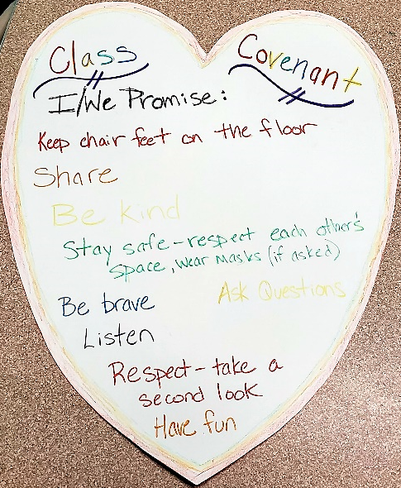
Sunday School Registration

Enrollment for 2022-23
Welcome to Memorial United Church of Christ’s Sunday School! Our school is where we learn the way of Jesus and discover how to love God with all our heart, mind and spirit. We also learn how to love our neighbor as our self. To help us plan for the year, we appreciate you taking a few minutes to fill out the spaces below, even if you will only be coming to Memorial’s Sunday School classes occasionally.

Name(s) and Age/birthday(s):

Grade(s) and School attending:

Parent or guardian, preferred method of contact information (name, address and phone, e-mail):

How often do you anticipate your children attending classes?

Please tell us your child’s special interests:

Please tell us your special concerns:
__________________________________________________________________________________________
__________________________________________________________________________________________
Any health concerns we need to be aware of (e.g., food allergies, asthma.): ___________________

__________________________________________________________________________________________

Is anyone else in your household? What is their relationship to you?

Can we use your child’s picture (we won’t use names):

___On our photo-boards in the church? ___ in printed publications? ___ on social media sites?
What are some of your favorite snack foods?

Any other stuff we ought to know (e.g. shyness, behavior, ADHD):

*Parents:
We welcome parent participation in our program. Below are ways that you as a parent can help out. Please consider being a volunteer (once, twice or as often as you like) for any of the following:

____Sunday assistance:
___teach a class
___assist with a class

____Faith Development Committee
__Parent representative on Faith Development Committee (meets quarterly)

Thank you so much for filling this out!
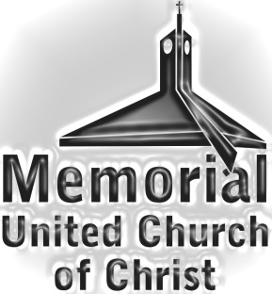
Rebecca Malke
Director of Faith Development
rebecca@memorialucc.org
(608) 273-1008

